<https://www.shopify.com/enterprise/ecommerce-fashion-industry>

### 1. Industry-Wide Data

Cumulative data compiled within [**The Fashion and Apparel Industry Report**](https://www.shopify.com/plus/industry-reports/fashion-and-apparel?itcat=plusblog&itterm=ecommerce-fashion-industry) paints a bright portrait with worldwide revenue expected to rise from $481.2 billion in 2018 to $712.9 billion by 2022:

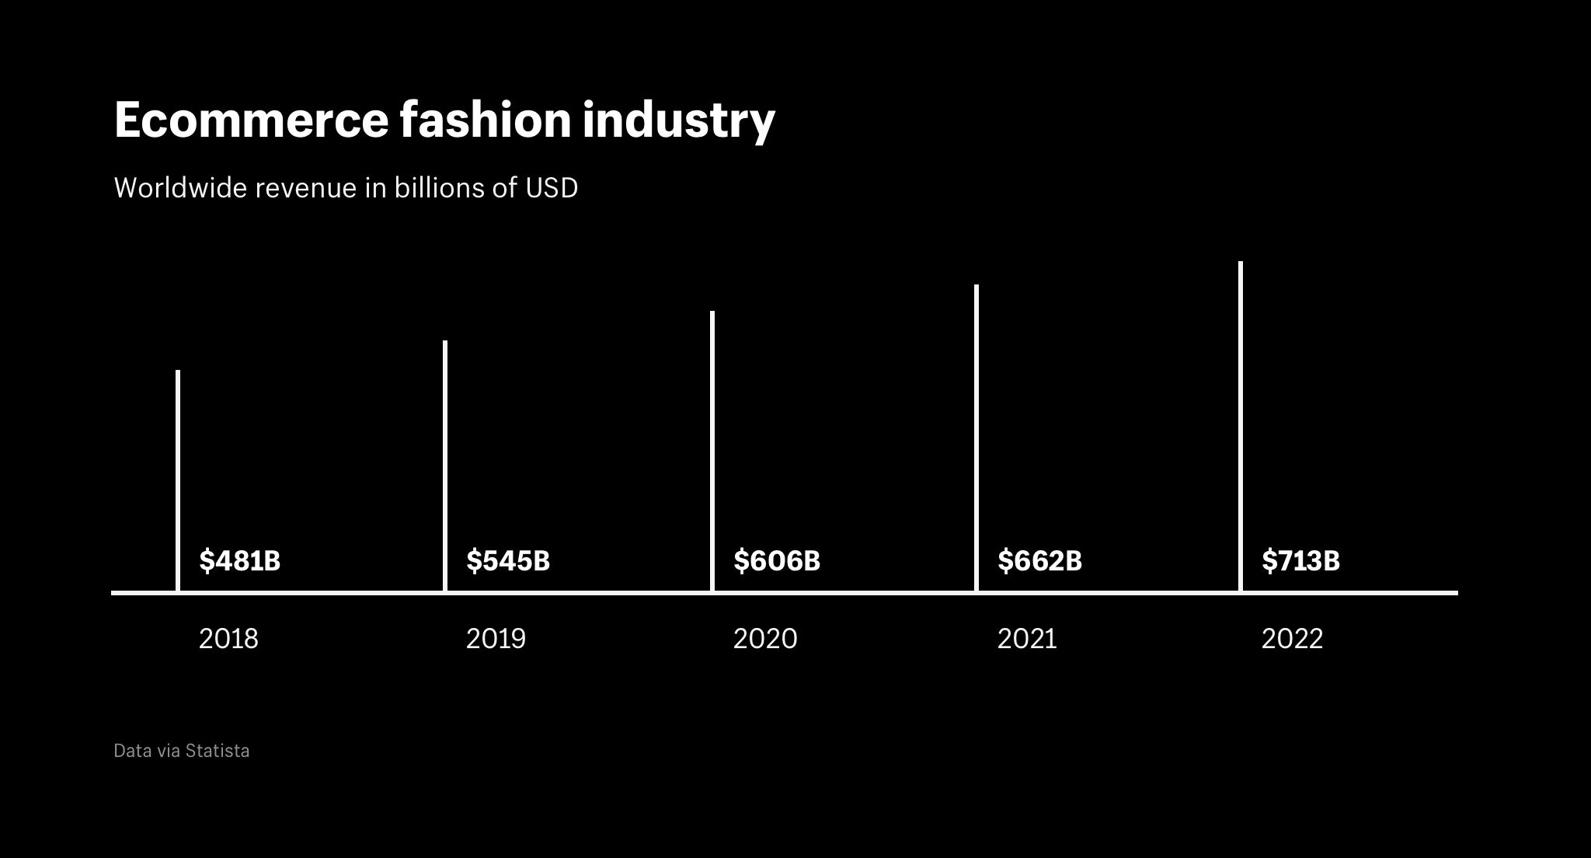

Data via Statista and accessible in [**The Fashion and Apparel Industry Report**](https://www.shopify.com/plus/industry-reports/fashion-and-apparel?itcat=plusblog&itterm=ecommerce-fashion-industry)

Driving this growth are four notable opportunities:

* Expanding global markets outside the West
* Increasing online access and smartphone penetration
* Emerging worldwide middle-classes with disposable income
* Innovating technologies to create experiential ecommerce

Fashion consumers will also have more buying power, as the number of potential customers is projected to grow to more than 1.2 billion by 2020. The good news for fashion is that the majority of these new consumers are within the 16 to 24 and 25 to 34 age groups.

The biggest threats to established brands include the:

* Death of brand loyalty due to market fragmentation
* Cost of combating online return rates as high as 50%
* Fast fashion’s ability to create and release styles on-demand
* Pressure from consumers to use ethically sourced and green manufacturing materials